|  |  |
| --- | --- |
| Name: | Prerna Sunil Jadhav |
| Sap Id: | 60004220127 |
| Class: | T. Y. B. Tech (Computer Engineering) |
| Course: | Advance Algorithm Laboratory |
| Course Code: | DJ19CEL602 |
| Experiment No.: | 02 |

**AIM: Hiring Problem**

**CODE:**

Ascending:

import random

candidate = [0, 1, 2, 3, 4, 5, 6, 7, 8, 9]

interview = []

hire = []

for i in range(0, 10):

  x = random.choice(candidate)

  candidate.remove(x)

  interview.append(x)

print(interview)

for i, num in enumerate(interview, 1):

  largest_num = max(interview[:i])

  print(f"Hired: {largest_num}, till {i} interviews")

  hire.append(largest_num)

print(hire)

print("The number of candidates hired is:", len(set(hire)))

cost = len(set(hire)) - 1

print("Thus firing cost will be:", cost)

**OUTPUT:**

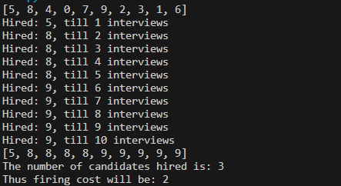

**Randomized:**

import random

candidates = [0, 1, 2, 3, 4, 5, 6, 7, 8, 9]

interviewed_candidates = []

hired_candidates = []

# Randomly select and interview candidates

for i in range(len(candidates)):

    selected_candidate = random.choice(candidates)

    interviewed_candidates.append(selected_candidate)

    candidates.remove(selected_candidate)

# Hire the best candidate so far

max=-1

for i in range(len(interviewed_candidates)):

    if interviewed_candidates[i] > max:

        max=interviewed_candidates[i]

        hired_candidates.append(interviewed_candidates[i])

# Calculate firing cost

firing_cost = len(hired_candidates) - 1

print("Interviewed candidates:", interviewed_candidates)

print("Hired candidates:", hired_candidates)

print("Number of candidates hired:", len(hired_candidates))

print("Firing cost:", firing_cost)

**OUTPUT:**

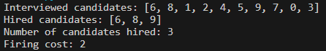

**CONCLUSION:**  Hence we implemented the Hiring Problem.